**Assignment - 1 (JavaScript)**

*19CSE445 – Cloud Computing*

1. Use HTML5 elements “Header” and “Main” for designing above webpage. Header element must contain “ADD NEW EMPLOYEE” and the Main element must contain rest of the webpage. (5 Marks)

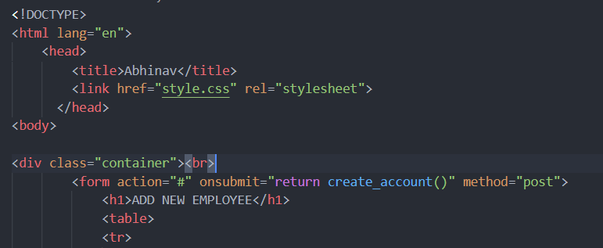

1. The “Add Record” Button can be used to validate the filled form. Also give directions to the users when errors occurred. (5 Marks)

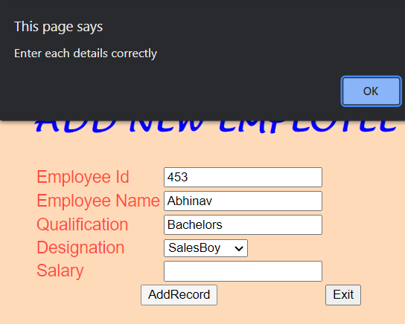

1. Apply following constrains in JS to validated the user input. (10 Marks)
   * Check the Employee Id is a number and No characters or alpha numerals are allowed.
   * Check the Employee name has only the characters and No numeric values are allowed
   * Qualification field can accept both the numeric value as well as text
   * Salary field must be a number No character data are allowed.
   * Use external style sheet for applying background colour and font details.

* **JS Code Code Added Below**

1. When all the details submitted by the user are correct redirect the user to Congratulation page otherwise the ask user to re-enter the correct details. (10 Marks)

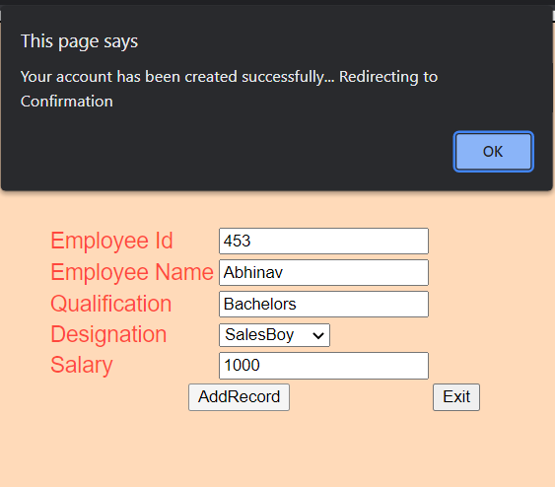

1. Reset the form details using the “Exit” button.

<input type="reset" id="reset" value="Exit"/>

**HTML:**

<!DOCTYPE>

<html lang="en">

    <head>

        <title>Abhinav</title>

        <link href="style.css" rel="stylesheet">

      </head>

<body>

<div class="container"><br>

        <form action="#" onsubmit="return create_account()" method="post">

            <h1>ADD NEW EMPLOYEE</h1>

            <table>

            <tr>

                <td class="tdLabel"><label for="number" class="label">Employee Id</label></td>

                <td class="d1"><input type="number" name="id" value="" id="id"/></td>

            </tr>

            <tr>

                <td class="tdLabel"><label for="text" class="label">Employee Name</label></td>

                <td><input type="text" name="name" id="name"/></td>

            </tr>

            <tr>

                <td class="tdLabel"><label for="register_email" class="label">Qualification</label></td>

                <td class="d1"><input type="text" name="qual" value="" id="qual"/></td>

            </tr>

            <tr>

                <td class="tdLabel"><label for="register_country" class="label">Designation</label></td>

                <td><select name="country" id="des">

                <option value="india">SalesBoy</option>

                <option value="pakistan">Marketing</option>

                <option value="africa">Accountant</option>

                <option value="china">Audit</option>

                <option value="other">other</option>

            </select>

            </td>

            </tr>

            <tr>

                <td class="tdLabel"><label for="register_name" class="label">Salary</label></td>

                <td><input type="number" name="number" value="" id="sal"/></td>

            </tr>

            <tr>

                <td colspan="2"><div align="center"><input type="submit" id="submit" value="AddRecord"

                     class="btn btn-success"    autocomplete="off" onClick="create_account()"/>

            </div></td>

            <td colspan="2"><div align="left"><input type="reset" id="reset" value="Exit"/>

            </tr>

            </table>

            </form>

        <br><br>

</div>

<script src="main.js"></script>

</body>

</html>

**CSS:**

body {

  font-family: "Open Sans", sans-serif;

  color: #272829;

}

a {

  color: #149ddd;

  text-decoration: none;

}

a:hover {

  color: #37b3ed;

  text-decoration: none;

}

h1,

h2,

h3,

h4,

h5,

h6 {

  font-family: "Lucida Handwriting", sans-serif;

  font-size: 35px;

  color: blue;

}

.container {

  border-radius: 5px;

  background-color: peachpuff;

  width: 400px;

  height: 330px;

  border: 2px solid black;

  padding: 50px;

  position: absolute;

  left: 27%;

}

.td {

  width: 160px;

  padding: 50px;

}

.tdLabel {

  font-size: 18px;

  color: rgba(255, 0, 0, 0.671);

}

.d1 {

  font-weight: italic;

}

**JS:**

function create_account(){

  var n=document.getElementById("id").value;

  var e=document.getElementById("name").value;

  var p=document.getElementById("qual").value;

  var cp=document.getElementById("des").value;

  var sl=document.getElementById("sal").value;

*//Code for validation*

          var letters = /^[A-Za-z]+$/;

          var numbers = /^[0-9]+$/;

          var email_val = /^([a-zA-Z0-9_\.\-])+\@(([a-zA-Z0-9\-])+\.)+([a-zA-Z0-9]{2,4})+$/;

*//other validations required code*

  if(n==''||e==''||p==''||cp==''||sl==''){

  alert("Enter each details correctly");

  }

  else if(!numbers.test(n))

          {

              alert('ID is incorrect must contain numbers only');

          }

  else if (!letters.test(e))

          {

              alert('Name is incorrect must contain characters only');

          }

  else if(!numbers.test(sl))

          {

              alert('ID is incorrect must contain numbers only');

          }

  else{

  alert("Your account has been created successfully... Redirecting to Confirmation");

  window.location="c.html";

  }

  }

**Final Output:**

